FULL STACK PROJECT REPORT

On

**Restaurant Reel**

**Submitted by**

Kartikeya Mishra(171500157)

Department of Computer Engineering &

Applications

**Institute of Engineering & Technology**



**GLA University**

**Mathura- 281406, INDIA**

**2019**



**Department of Computer Engineering and Applications**

**GLA UNIVERSITY, MATHURA**

**17km.Stone NH#2, Mathura-Delhi Road, P.O. – Chaumuha,**

**Mathura-281406**

m

**Declaration**

We hereby declare that the work which is being presented in the Full Stack Project “**Restaurant Reel”,** in partial fulfillment of the requirements for Full Stack Project viva voce, is an authentic record of my own work carried under the supervision of “**Mr. Pankaj Kapoor**”.

**Signature of Candidate:**

**Name of Candidate:**Kartikeya Mishra (171500157)

**Course:** B.TECH (CSE)

**Year:** 3rd

**Semester:** 5th

**Acknowledgement**

I have taken efforts in this project. However, it would not have been possible without the kind support and help of many individuals. On the completion of this project, we would like to extend my sincere thanks to all of them. I am highly indebted to this project guide **Mr. Pankaj Kapoor** for their guidance and constant supervision as well as for providing necessary information regarding the project. I wish to extend my sincere gratitude to **Prof. Anand Singh Jalal, Head of Department of Computer Engineering and Applications** and faculty of CEA Department of **GLA University** for their guidance, encouragement and give this opportunity and valuable suggestion which prove extremely useful and helpful in the completion of this report. I would also like to thank all those who directly or indirectly supported or helped me in completing my project in time. I would like to express my gratitude towards my parents and member of my college for their kind cooperation and encouragement which helped me in completion of this project. All of them have willingly helped me out with their abilities.

**Abstract**

Online review sites have transformed the way we do business and the way your customers make decisions. Additionally, review sites help your potential customers weed out their choices. Reviews help them decide if they’re going to stop into your restaurant or the competition’s. Public opinion has taken over the Internet, and if you aren’t currently perusing review sites, it’s time to find out what your customers think

Most people rely on reviews when choosing a place to go with their friends or family. Many studies have proven that the selective process of most people involves looking for reviews and testimonials from other people about the venue. People tend to look at the number of reviews and the quality when it comes to selecting the place they want to go. This is why websites such as Yelp are held in such high regard. It makes the selection process easier for people who do not want to do all the research themselves and would rather trust an authority source to make their decision. This is human nature that applies to almost all decisions that we make where we want to conserve time and energy and not have to spend too much of either of these things that can be done in a more time-efficient manner.

This is why restaurant owners must make it a point to manage their reputation effectively and focus on customer service as much as the quality of food. Good social presence on the Internet also helps with this. As you can see, running a restaurant is no less effort than running any other business. In fact, it arguably involves more work due to its hands-on nature and its volatility.

**CONTENTS**

**Acknowledgement….…………………………………………………iii**

**Abstract……………………………………………………………....iv**

1. **Introduction………………………………………………………1**

* 1. Motivation….………………………………………..…………...1
  2. Objective………………………………………………………….1
  3. What is Web Development..…………………………………...…2
  4. What is Website……...……………………………………………3
  5. What is Webpage………………………………………………….4

1. **Software Requirements…………………………………………..5**
   1. Problem Statement………………………………………………..5
   2. Technologies Used……………..…………………………………5
   3. Software Used.……………………………………………………9
2. **Software Design…………………………………………………10**
   1. DFD………………………………………………………………10
3. **Implementation and User Interface…………………………….15**
   1. Web Page Details…………………………………………………15
   2. Detailed Description Of Pages…………………………………....15
4. **Conclusion and Future Aspect…….……………………………..20**
   1. Conclusion………………………………………………………..20
   2. Future Aspects……………………………………………………20
5. **Bibliography ……………………………………………………...21**
6. **Appendices………………………………………………………....22**

**CHAPTER 1**

**Introduction**

* 1. **Motivation**

The main objective of **“Restaurant Reel”** is that it provides the visitor or user the reviewed Restaurant. In this website the user can look the rating of Top Restaurant Present in Mathura. Since, Mathura is a birth Place of Lord Krishna, and the visitor must get the top rated Restaurant for having the stuff.

* 1. **Objective**

“**Restaurant Reel**” is the way of giving/providing information to related to the best rated Restaurant in Mathura, because Online review sites have transformed the way we do business and the way your customers make decisions. Additionally, review sites help your potential customers weed out their choices. Reviews help them decide if they’re going to stop into your restaurant or the competition’s.Public opinion has taken over the Internet, and if you aren’t currently perusing review sites, it’s time to find out what your customers think

**1.3 What is Web Development?**

**Web development** is the work involved in developing a [web site](https://en.wikipedia.org/wiki/Web_site) for the [Internet](https://en.wikipedia.org/wiki/Internet) ([World Wide Web](https://en.wikipedia.org/wiki/World_Wide_Web)) or an [intranet](https://en.wikipedia.org/wiki/Intranet) (a private network). Web development can range from developing a simple single [static page](https://en.wikipedia.org/wiki/Static_web_page) of [plain text](https://en.wikipedia.org/wiki/Plain_text) to complex web-based [internet applications](https://en.wikipedia.org/wiki/Internet_application) (web apps), [electronic businesses](https://en.wikipedia.org/wiki/Electronic_business), and [social network services](https://en.wikipedia.org/wiki/Social_network_service). A more comprehensive list of tasks to which web development commonly refers, may include [web engineering](https://en.wikipedia.org/wiki/Web_engineering), [web design](https://en.wikipedia.org/wiki/Web_design), [web content development](https://en.wikipedia.org/wiki/Web_content_development), client liaison, [client-side](https://en.wikipedia.org/wiki/Client-side_scripting)/[server-side](https://en.wikipedia.org/wiki/Server-side_scripting) [scripting](https://en.wikipedia.org/wiki/Computer_programming), [webserver](https://en.wikipedia.org/wiki/Web_server) and network configuration

Among web professionals, "web development" usually refers to the main non-design aspects of building web sites: writing [markup](https://en.wikipedia.org/wiki/Markup_language) and [coding](https://en.wikipedia.org/wiki/Computer_programming). Web development may use [content management systems](https://en.wikipedia.org/wiki/Content_management_system) (CMS) to make content changes easier and available with basic technical skills.

For larger organizations and businesses, web development teams can consist of hundreds of people ([web developers](https://en.wikipedia.org/wiki/Web_developer)) and follow standard methods like [Agile methodologies](https://en.wikipedia.org/wiki/Agile_software_development) while developing websites. Smaller organizations may only require a single permanent or contracting developer, or secondary assignment to related job positions such as a [graphic designer](https://en.wikipedia.org/wiki/Graphic_designer) or [information systems](https://en.wikipedia.org/wiki/Information_systems) technician. Web development may be a collaborative effort between departments rather than the domain of a designated department. There are three kinds of web developer specialization: [front-end developer](https://en.wikipedia.org/wiki/Front-end_web_development), back-end developer, and [full-stack developer](https://en.wikipedia.org/wiki/Full-stack_developer).

**1.4 What is Website?**

A **website** or **web site** is a collection of related network [web resources](https://en.wikipedia.org/wiki/Web_resource), such as web pages, [multimedia](https://en.wikipedia.org/wiki/Multimedia) content, which are typically identified with a common [domain name](https://en.wikipedia.org/wiki/Domain_name), and published on at least one [web server](https://en.wikipedia.org/wiki/Web_server). Notable examples are [wikipedia.org](https://en.wikipedia.org/wiki/Wikipedia), [google.com](https://en.wikipedia.org/wiki/Google), and [amazon.com](https://en.wikipedia.org/wiki/Amazon_(company)).

Websites can be accessed via a public [Internet Protocol](https://en.wikipedia.org/wiki/Internet_Protocol) (IP) network, such as the [Internet](https://en.wikipedia.org/wiki/Internet), or a private [local area network](https://en.wikipedia.org/wiki/Local_area_network) (LAN), by a [uniform resource locator](https://en.wikipedia.org/wiki/URL) (URL) that identifies the site.

Websites can have many functions and can be used in various fashions; a website can be a [personal website](https://en.wikipedia.org/wiki/Personal_website), a corporate website for a company, a government website, an organization website, etc. Websites are typically dedicated to a particular topic or purpose, ranging from entertainment and [social networking](https://en.wikipedia.org/wiki/Social_networking) to providing news and education. All publicly accessible websites collectively constitute the [World Wide Web](https://en.wikipedia.org/wiki/World_Wide_Web), while private websites, such as a company's website for its employees, are typically part of an [intranet](https://en.wikipedia.org/wiki/Intranet).

**1.5 What is Webpage?**

A web page is a document that is suitable to act as a [web resource](https://en.wikipedia.org/wiki/Web_resource) on the [World Wide Web](https://en.wikipedia.org/wiki/World_Wide_Web). In order to graphically display a web page, a [web browser](https://en.wikipedia.org/wiki/Web_browser) is needed. This is a type of [software](https://en.wikipedia.org/wiki/Application_software) that can retrieve web pages from the [Internet](https://en.wikipedia.org/wiki/Internet). When accessed by a web browser it may be displayed as a web page on a [monitor](https://en.wikipedia.org/wiki/Computer_display) or [mobile device](https://en.wikipedia.org/wiki/Mobile_device). Typical web pages are [hypertext](https://en.wikipedia.org/wiki/Hypertext) documents which contain [hyperlinks](https://en.wikipedia.org/wiki/Hyperlink), often referred to as *links*, for browsing to other web pages.

The term web page usually refers to what is visible, but may also refer to the contents of the [source code](https://en.wikipedia.org/wiki/Source_code) itself, which is usually a [text file](https://en.wikipedia.org/wiki/Text_file) containing [hypertext](https://en.wikipedia.org/wiki/Hypertext) written in [HTML](https://en.wikipedia.org/wiki/HTML) or a comparable [markup language](https://en.wikipedia.org/wiki/Markup_language). Most current web browsers include the ability to view the source code. Web browsers will frequently have to access multiple [web resource](https://en.wikipedia.org/wiki/Web_resource) elements, such as [style sheets](https://en.wikipedia.org/wiki/Cascading_Style_Sheets), [scripts](https://en.wikipedia.org/wiki/Client-side_scripting), and images, while presenting each web page.

**CHAPTER 2**

**Software Requirement**

**2.1 Problem Statement**

Online review sites have transformed the way we do business and the way your customers make decisions. Additionally, review sites help your potential customers weed out their choices. Reviews help them decide if they’re going to stop into your restaurant or the competition’s. Public opinion has taken over the Internet, and if you aren’t currently perusing review sites, it’s time to find out what your customers think.

* 1. **Technologies used**

1. **HTML:** Hypertext Markup Language (HTML) is the standard [markup language](https://en.wikipedia.org/wiki/Markup_language) for documents designed to be displayed in a [web browser](https://en.wikipedia.org/wiki/Web_browser). It can be assisted by technologies such as [Cascading Style Sheets](https://en.wikipedia.org/wiki/Cascading_Style_Sheets) (CSS) and [scripting languages](https://en.wikipedia.org/wiki/Scripting_language) such as [JavaScript](https://en.wikipedia.org/wiki/JavaScript).

**General Syntax of HTML:**

<! DOCTYPE html>  
<html>  
<head>  
<title>Page Title</title>  
</head>  
<body>  
  
<h1>My First Heading</h1>  
<p>My first paragraph.</p>  
  
</body>  
</html>

1. **CSS: Cascading Style Sheets (CSS)** is a [style-sheet](https://developer.mozilla.org/en-US/docs/DOM/stylesheet) language used to describe the presentation of a document written in [HTML](https://developer.mozilla.org/en-US/docs/Web/HTML) or [XML](https://developer.mozilla.org/en-US/docs/XML_introduction) (including XML dialects such as [SVG](https://developer.mozilla.org/en-US/docs/Web/SVG), [Math-ML](https://developer.mozilla.org/en-US/docs/Web/MathML) or [XHTML](https://developer.mozilla.org/en-US/docs/Glossary/XHTML)). CSS describes how elements should be rendered on screen, on paper, in speech, or on other media.

CSS is one of the core languages of the **open Web** and is standardized across Web browsers according to the [W3C specification](http://w3.org/Style/CSS/#specs). Developed in levels, CSS1 is now obsolete, CSS2.1 is a recommendation, and [CSS3](https://developer.mozilla.org/en-US/docs/Web/CSS/CSS3), now split into smaller modules, is progressing on the standardization track.

**Types of CSS:**

**2.1** **Inline CSS**: It will affect only single elements. In HTML we require that various HTML tag's views are different so then we use inline Cascading Style Sheets. There are disadvantage of inline Cascading Style Sheets. It must be specified on every HTML tag. There is a lot of time consumed by that and it is not the best practice for a good programmer and the code will be quite large and very complex.

**2.2** **Internal CSS**: In internal CSS the style of CSS is specified in the <head> section. This is internal CSS, it affects all the elements in the body section. Internal CSS is used in the condition when we want a style to be used in the complete HTML body. For that we can use style in the head tag.

**2.3 External CSS**: In External CSS we create a .css file and use it in our HTML page as per our requirements. Generally external Cascading Style Sheets are used whenever we have many HTML attributes and we can use them as required; there is no need to rewrite the CSS style again and again in a complete body of HTML that inherits the property of the CSS file. There are two ways to create a CSS file. The first is to write the CSS code in Notepad and save it as a .css file, the second one is to directly add the style sheet in our Solution Explorer and direct Visual Studio to use it on our HTML page.

1. **Bootstrap:** Bootstrap is a [free and open-source](https://en.wikipedia.org/wiki/Free_and_open-source) [CSS framework](https://en.wikipedia.org/wiki/CSS_framework) directed at responsive, mobile-first [front-end web development](https://en.wikipedia.org/wiki/Front-end_web_development). It contains [CSS](https://en.wikipedia.org/wiki/CSS)- and (optionally) [JavaScript](https://en.wikipedia.org/wiki/JavaScript) based design templates for [typography](https://en.wikipedia.org/wiki/Web_design#Typography), [forms](https://en.wikipedia.org/wiki/Form_(HTML)), [buttons](https://en.wikipedia.org/wiki/Button_(computing)#HTML), [navigation](https://en.wikipedia.org/wiki/Web_navigation#Local_website_navigation) and other interface components. Bootstrap is the third-most-starred project on [Git-Hub](https://en.wikipedia.org/wiki/GitHub), with more than 135,000 stars, behind only [free Code Camp](https://en.wikipedia.org/wiki/FreeCodeCamp) (almost 305,000 stars) and marginally behind [Vue.js](https://en.wikipedia.org/wiki/Vue.js) framework. According to [Alexa Rank](https://en.wikipedia.org/wiki/Alexa_Internet), Bootstrap getbootstrap.com is in the top-2000 in US while vuejs.org is in top-7000 in US. Bootstrap, originally named Twitter Blueprint, was developed by Mark Otto and Jacob Thornton at [Twitter](https://en.wikipedia.org/wiki/Twitter) as a framework to encourage consistency across internal tools. Before Bootstrap, various libraries were used for interface development, which led to inconsistencies and a high maintenance burden.
   1. **Software Used**

**2.3.1 Brackets (text-editor):** It is a [source code editor](https://en.wikipedia.org/wiki/Source_code_editor) with a primary focus on web   development. Created by [Adobe Systems](https://en.wikipedia.org/wiki/Adobe_Systems), it is [free and open-source software](https://en.wikipedia.org/wiki/Free_and_open-source_software) licensed under the [MIT License](https://en.wikipedia.org/wiki/MIT_License), and is currently maintained on [Git-Hub](https://en.wikipedia.org/wiki/GitHub) by Adobe and other open-source developers. It is written in [JavaScript](https://en.wikipedia.org/wiki/JavaScript), [HTML](https://en.wikipedia.org/wiki/HTML) and [CSS](https://en.wikipedia.org/wiki/CSS). Brackets is [cross-platform](https://en.wikipedia.org/wiki/Cross-platform), available for [mac-OS](https://en.wikipedia.org/wiki/MacOS), [Windows](https://en.wikipedia.org/wiki/Microsoft_Windows), and most [Linux distributions](https://en.wikipedia.org/wiki/Linux_distribution). The main purpose of brackets is its live [HTML](https://en.wikipedia.org/wiki/HTML), [CSS](https://en.wikipedia.org/wiki/Cascading_Style_Sheets) and [JavaScript](https://en.wikipedia.org/wiki/JavaScript) editing functionality.

[Adobe](https://en.wikipedia.org/wiki/Adobe_Systems) first started development of a text editor for [web development](https://en.wikipedia.org/wiki/Web_development) on [Edge Code](https://en.wikipedia.org/wiki/Adobe_Edge), which was discontinued. This was later transformed into [Adobe](https://en.wikipedia.org/wiki/Adobe_Systems) Brackets. With the release of Brackets 1.0, [Adobe](https://en.wikipedia.org/wiki/Adobe_Systems) announced that the development of an open source software for [web development](https://en.wikipedia.org/wiki/Web_development) was ready and was not an experimental project anymore. Brackets contains more than 282 community contributors and more than 400 requests for bug fixes and new features. Every version of Brackets has more than 100,000 downloads and stands to be 16th most popular project on [Git-Hub](https://en.wikipedia.org/wiki/GitHub).

**CHAPTER 3**

**Software Design**

**3.1 DFD**

A **data-flow diagram** (DFD) is a way of representing a flow of a data of a [process](https://en.wikipedia.org/wiki/Process) or a system (usually an [information system](https://en.wikipedia.org/wiki/Information_system)). The DFD also provides information about the outputs and inputs of each entity and the process itself. A data-flow diagram has no control flow, there are no decision rules and no loops. Specific operations based on the data can be represented by a [flowchart](https://en.wikipedia.org/wiki/Flowchart).

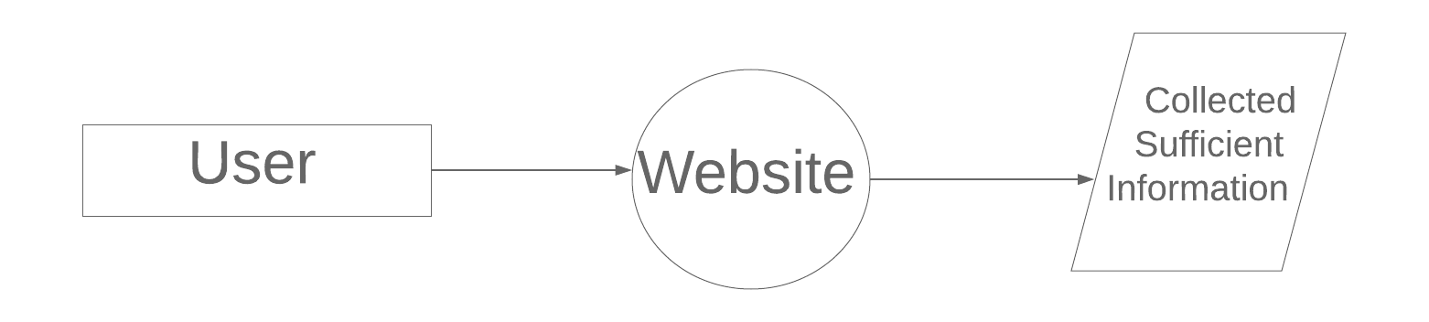

Fig No. 3.1 DFD LEVEL-0

**CHAPTER 4**

**Implementation and User Interface**

**4.1 Web Page Details**

1. Home Page
2. About Us
3. Top 6 Restaurant present in Mathura
4. Write a Review
5. People Reviewed

**4.2 Detailed Description of Pages**

**1. Home Page** The home screen consists of screen where one can browse through the page for getting information about the usefulness of the web page

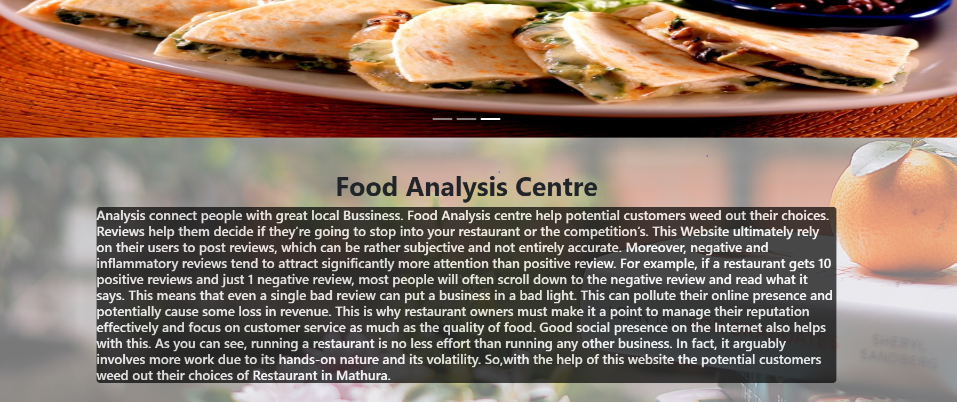

Fig No. 4.1 Home Page

1. **Top 6 Restaurant Page:** The screen consists of screen where one can browse through the top 6 best Rated Restaurant present in Mathura.

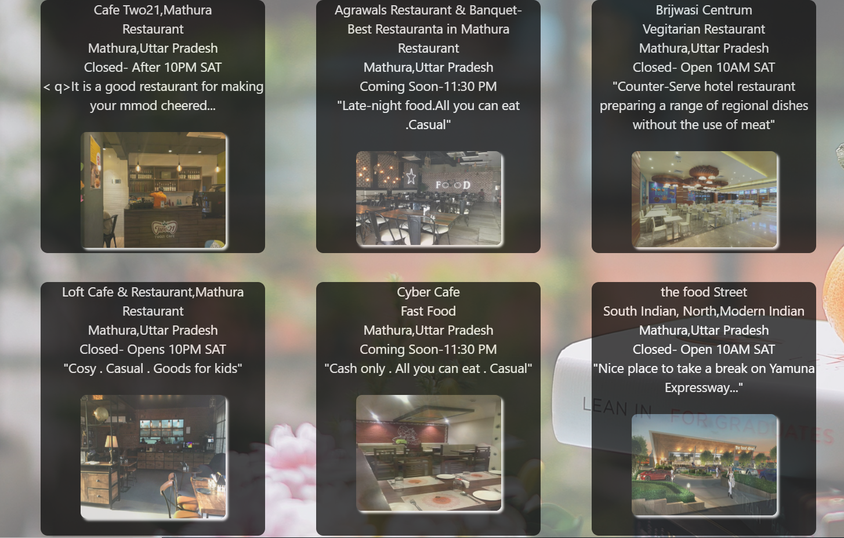

Fig No. 4.3 2. Top 6 Restaurant Page

1. **Write Your Review:** User can also Write a Review of any stuff for any Restaurant Present in Mathura, Because public opinion matters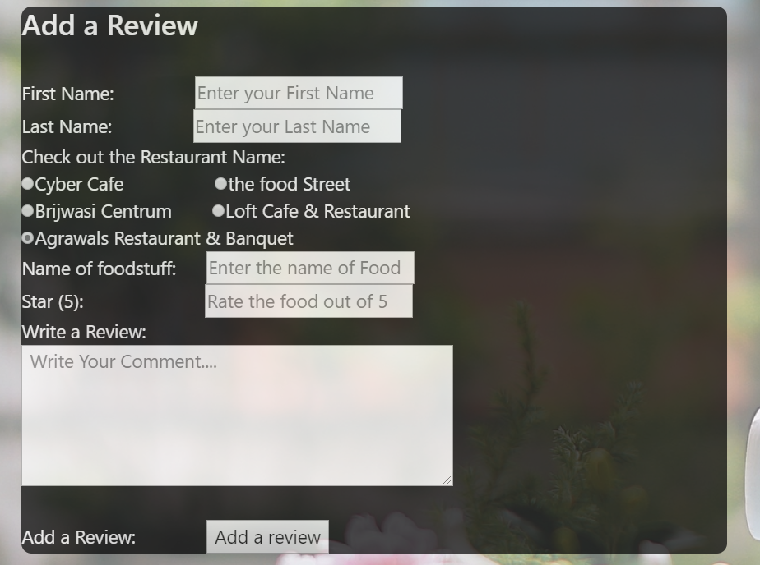

Fig 4.3 Products Page

1. **Review of the Day: –** Here on the Screen some Review Added by the user will be shown.

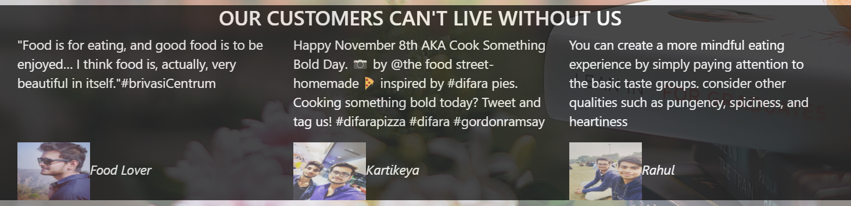

Fig 4.5 Review of the Day Page

CHAPTER 5

# Conclusion and Future Aspects

**5.1 Conclusion**

We have successfully implemented the website “**Restaurant Reel**” . With the help of various links and tools, we have been able to provide a site which will be live soon and running on the web. We have been successful in our attempt to take care of the needs of both the user as well as the administration. Finally we hope that this will go a long way in popularizing.

**5.2 Future Aspects**

1. We can add query box
2. We can add the review of newly opened Restaurant
3. We can add sms tool so that the information about the Restaurant can be provided using SMS.

**CHAPTER 6**

**Bibliography**

* <https://www.w3schools.com/html/default.asp>
* <https://www.w3schools.com/css/default.asp>
* <https://www.w3schools.com/bootstrap4/default.asp>
* <https://mdbootstrap.com/docs/jquery/javascript/carousel/>

# CHAPTER 7

# Appendices

**7.1 CSS**

1. /*      CSS for the BackGround Image*/
2. .back{
3. **background-image**: url(../Image/bg_hd%20wallpaper.jpg);
4. **width**: 100%;
5. **height**: 100%;
6. **position**: fixed;
7. top: 0;
8. opacity: 0.6;
9. }
11. /*        CSS for the Description About the web Page*/
12. .description{
13. **background-color**: black;
14. border-radius: 5px;
15. opacity: 0.7;
16. **color**: white;
17. }

20. /*        CSS for the top 6 Restaurant*/
21. .customdiv
22. {
23. **margin**: 20px;
24. **background-color**: black;
25. **text-align**: center;
26. **min-height**:350px;
27. **font-size**: 18px;
28. **overflow**: hidden;
29. border-radius: 10px;
30. opacity: 0.7;
31. }
32. /*          CSS for Styling the Information Present in the top 6 Restaurant*/
34. .info{
35. **color**: white;
36. }
38. /*        CSS for Styling the Review Centre*/
40. .review
41. {
42. **margin**: 2px;
43. **min-height**:350px;
44. **font-size**: 18px;
45. **overflow**: hidden;
46. }

49. .customdiv2{
50. **margin**: 20px;
51. **background-color**: black;
52. **color**: white;
53. **max-height**:950px;
54. **font-size**: 18px;
55. **overflow**: hidden;
56. border-radius: 10px;
57. opacity: 0.7;
58. }

**7.2 HEAD**

1. <!DOCTYPE html**>**
2. **<html** lang=""**>**
3. **<head>**
4. **<meta** charset="utf-8"**>**
5. **<meta** name="viewport" content="width=device-width, initial-scale=1.0"**>**
6. **<title>**Food Analysis Centre**</title>**
7. **<link** rel="stylesheet" href="https://stackpath.bootstrapcdn.com/bootstrap/4.3.1/css/bootstrap.min.css" integrity="sha384-ggOyR0iXCbMQv3Xipma34MD+dH/1fQ784/j6cY/iJTQUOhcWr7x9JvoRxT2MZw1T" crossorigin="anonymous"**>**
8. **<script** src="https://code.jquery.com/jquery-3.2.1.slim.min.js" integrity="sha384-KJ3o2DKtIkvYIK3UENzmM7KCkRr/rE9/Qpg6aAZGJwFDMVNA/GpGFF93hXpG5KkN" crossorigin="anonymous"**></script>**
9. **<script** src="https://cdnjs.cloudflare.com/ajax/libs/popper.js/1.12.9/umd/popper.min.js" integrity="sha384-ApNbgh9B+Y1QKtv3Rn7W3mgPxhU9K/ScQsAP7hUibX39j7fakFPskvXusvfa0b4Q" crossorigin="anonymous"**></script>**
10. **<script** src="https://maxcdn.bootstrapcdn.com/bootstrap/4.0.0/js/bootstrap.min.js" integrity="sha384-JZR6Spejh4U02d8jOt6vLEHfe/JQGiRRSQQxSfFWpi1MquVdAyjUar5+76PVCmYl" crossorigin="anonymous"**></script>**

**7.3 Navigation Bar**

1. <!--     Code for Navigation Bar-->
2. **<nav** class="navbar navbar-expand-lg navbar-light bg-info navbar-dark"**>**
3. **<a** class="navbar-brand" href="#"**>**About Us**</a>**
4. **<button** class="navbar-toggler" type="button" data-toggle="collapse" data-target="#navbarSupportedContent" aria-controls="navbarSupportedContent" aria-expanded="false" aria-label="Toggle navigation"**>**
5. **<span** class="navbar-toggler-icon"**></span>**
6. **</button>**
8. **<div** class="collapse navbar-collapse" id="navbarSupportedContent"**>**
9. **<ul** class="navbar-nav mr-auto"**>**
10. **<li** class="nav-item active"**>**
11. **<a** class="nav-link" href="#"**>**Home **<span** class="sr-only"**>**(current)**</span></a>**
12. **</li>**
13. **<li** class="nav-item"**>**
14. **<a** class="nav-link" href="#"**>**Write A Review**</a>**
15. **</li>**
16. **<li** class="nav-item dropdown"**>**
17. **<a** class="nav-link dropdown-toggle" href="#" id="navbarDropdown" role="button" data-toggle="dropdown" aria-haspopup="true" aria-expanded="false"**>**
18. Rewards
19. **</a>**
20. **<div** class="dropdown-menu" aria-labelledby="navbarDropdown"**>**
21. **<a** class="dropdown-item" href="#"**>**Top 6 Restaurant**</a>**
22. **<a** class="dropdown-item" href="#"**>**Coupons**</a>**
23. **<div** class="dropdown-divider"**></div>**
24. **<a** class="dropdown-item" href="#"**>**Religious Food**</a>**
25. **</div>**
26. **</li>**
27. **</ul>**
28. **<form** class="form-inline my-2 my-lg-0"**>**
29. **<input** class="form-control mr-sm-2" type="search" placeholder="Search" aria-label="Search"**>**
30. **<button** class="btn btn-outline-success my-2 my-sm-0" type="submit"**>**Search**</button>**
31. **</form>**
32. **</div>**
33. **</nav>**

**7.4 Carousel Card**

1. <!--      Body Section for Image Carousel   -->


5. **<div** id="carouselExampleIndicators" class="carousel slide" data-ride="carousel"**>**
6. **<ol** class="carousel-indicators"**>**
7. **<li** data-target="#carouselExampleIndicators" data-slide-to="0" class="active"**></li>**
8. **<li** data-target="#carouselExampleIndicators" data-slide-to="1"**></li>**
9. **<li** data-target="#carouselExampleIndicators" data-slide-to="2"**></li>**
10. **</ol>**
11. **<div** class="carousel-inner"**>**
12. **<div** class="carousel-item active"**>**
13. **<img** class="d-block w-100" src="../Image/costa.jpg" height="450" width="80%" alt="First slide"**>**
14. **</div>**
15. **<div** class="carousel-item"**>**
16. **<img** class="d-block w-100" src="../Image/food3.jpg" height="450" width="80%" alt="Second slide"**>**
17. **</div>**
18. **<div** class="carousel-item"**>**
19. **<img** class="d-block w-100" src="../Image/food5.jpg" height="450" width="80%" alt="Third slide"**>**
20. **</div>**
21. **</div>**
22. **<a** class="carousel-control-prev" href="#carouselExampleIndicators" role="button" data-slide="prev"**>**
23. **<span** class="carousel-control-prev-icon" aria-hidden="true"**></span>**
24. **<span** class="sr-only"**>**Previous**</span>**
25. **</a>**
26. **<a** class="carousel-control-next" href="#carouselExampleIndicators" role="button" data-slide="next"**>**
27. **<span** class="carousel-control-next-icon" aria-hidden="true"**></span>**
28. **<span** class="sr-only"**>**Next**</span>**
29. **</a>**
30. **</div>**

**7.5 Description About the Page**

1. **<div** class="container"**>**
2. **<div** class="row"**>**
3. **<div** class="col-md-12"**>**
4. **<div** class="description"**>**
5. **<h5><p>**
6. Analysis connect people with great local Bussiness. Food Analysis centre help potential customers weed out their choices. Reviews help them decide if they’re going to stop into your restaurant or the competition’s.
7. This Website ultimately rely on their users to post reviews, which can be rather subjective and not entirely accurate. Moreover, negative and inflammatory reviews tend to attract significantly more attention than positive review. For example, if a restaurant gets 10 positive reviews and just 1 negative review, most people will often scroll down to the negative review and read what it says. This means that even a single bad review can put a business in a bad light. This can pollute their online presence and potentially cause some loss in revenue.
8. This is why restaurant owners must make it a point to manage their reputation effectively and focus on customer service as much as the quality of food. Good social presence on the Internet also helps with this. As you can see, running a restaurant is no less effort than running any other business. In fact, it arguably involves more work due to its hands-on nature and its volatility.
9. So,with the help of this website the potential customers weed out their choices of Restaurant in Mathura.
10. **</p>**
11. **</h5>**
13. **</div>**
14. **</div>**
15. **</div>**
16. <!--   End of  div tag for container class(description )-->
17. **</div>**

**7.6 Top 6 Restaurant present in Mathura**

1. **<div** class="container" **>**
2. **<div** class="row"**>**
4. **<div** class="col-md-4"**>**
5. **<div** class="customdiv"**>**
6. **<div** class="info"**><p>**Cafe Two21,Mathura **<br>**Restaurant**<br>**Mathura,Uttar Pradesh**<br>**Closed- After 10PM SAT**<br>**
7. **<** **q>**It is a good restaurant for making your mmod cheered...**</q><br></p></div>**
8. **<div** class="img"**>**
9. **<img** src="https://media-cdn.tripadvisor.com/media/photo-s/13/6d/67/99/two21-cafe-speedmart.jpg" height="160"  width="200" style="border-radius:8px;margin-top: 8px;box-shadow: 3px 3px 3px white " alt=""**>**
10. **</div>**
11. **</div>**
12. **</div>**

15. **<div** class="col-md-4"**>**
16. **<div** class="customdiv"**>**
17. **<div** class="info"**>**
18. **<p>**Agrawals Restaurant & Banquet-**<br>**Best Restauranta in Mathura**<br>**Restaurant**<br>**Mathura,Uttar Pradesh**<br>**Coming Soon-11:30 PM**<br><q>**Late-night food.All you can eat  .Casual**</q><br></p></div>**
19. **<div** class="img"**>**
20. **<img** src="https://content3.jdmagicbox.com/comp/mathura/j4/9999px565.x565.160322114948.g9j4/catalogue/agrawal-restaurant-mathura-bypass-mathura-restaurants-3s2ca.jpg" height="130"  width="200" style="border-radius:8px;margin-top: 8px;box-shadow: 3px 3px 3px white " alt=""**>**
21. **</div>**
22. **</div>**
23. **</div>**

26. **<div** class="col-md-4"**>**
27. **<div** class="customdiv"**>**
28. **<div** class="info"**>**
29. **<p>**Brijwasi Centrum**<br>**Vegitarian Restaurant**<br>**Mathura,Uttar Pradesh**<br>**Closed- Open 10AM SAT**<br>**
30. **<q>**Counter-Serve hotel restaurant preparing a range of regional dishes without the use of meat**</q><br></p>**
31. **</div>**
32. **<div** class="img"**>**
33. **<img** src="https://q-cf.bstatic.com/images/hotel/max1024x768/106/106538346.jpg" width="200" style="border-radius:8px;margin-top: 8px;box-shadow: 3px 3px 3px white " alt=""**>**
34. **</div>**
35. **</div>**
36. **</div>**
37. <!--            End of the div tag of the 1st Row of the top three Restaurant-->
38. **</div>**
40. <!--              Starting of 2nd Row-->
41. **<div** class="row"**>**
43. **<div** class="col-md-4"**>**
44. **<div** class="customdiv"**>**
45. **<div** class="info"**>**
46. **<p>**Loft Cafe & Restaurant,Mathura **<br>**Restaurant**<br>**Mathura,Uttar Pradesh**<br>**Closed- Opens 10PM SAT**<br>**
47. **<q>**Cosy  .  Casual  .  Goods for kids**</q><br></p>**
48. **</div>**
49. **<div** class="img"**>**
50. **<img** src="https://content3.jdmagicbox.com/comp/mathura/k4/9999px565.x565.181017163829.d1k4/catalogue/loft-cafe-mathura-0jnn2fwuu7.jpg" height="170"  width="200" style="border-radius:8px;margin-top: 8px;box-shadow: 3px 3px 3px white " alt=""**>**
51. **</div>**
52. **</div>**
53. **</div>**

56. **<div** class="col-md-4"**>**
57. **<div** class="customdiv"**>**
58. **<div** class="info"**>**
59. **<p>**Cyber Cafe**<br>**Fast Food **<br>**Mathura,Uttar Pradesh**<br>**Coming Soon-11:30 PM**<br><q>**Cash only  . All you can eat  . Casual**</q>** **<br></p>**
60. **</div>**
61. **<div** class="img"**>**
62. **<img** src="https://media-cdn.tripadvisor.com/media/photo-s/12/f1/40/27/4-6-seater-tables.jpg" height="160" width="200" style="border-radius:8px;margin-top: 8px;box-shadow: 3px 3px 3px white " alt=""**>**
63. **</div>**
64. **</div>**
65. **</div>**

68. **<div** class="col-md-4"**>**
69. **<div** class="customdiv"**>**
70. **<div** class="info"**>**
71. **<p>**the food Street**<br>**South Indian, North,Modern Indian**<br>**Mathura,Uttar Pradesh**<br>**Closed- Open 10AM SAT**<br>**
72. **<q>**Nice place to take a break on Yamuna Expressway...**</q><br></p>**
73. **</div>**
74. **<div** class="img"**>**
75. **<img** src="https://i2.wp.com/viriddesignworks.com/wp-content/uploads/2018/04/cam03_View01.jpg?fit=1200%2C675" width="200" height="140" style="border-radius:8px;margin-top: 8px;box-shadow: 3px 3px 3px white " alt=""**>**
76. **</div>**
77. **</div>**
78. **</div>**
79. <!--            End of the Div tag for the next 3 Top Ratted Reastaurant-->
80. **</div>**

**7.7. Review Matters**

1. <!-- review centre -->
2. ;!--             The Following code is for the review corner,where user can review the food of the Restaurant--**>**
3. **<div** class="row"**>**
5. <!-- FEEDBACK MATTERS-->
6. **<div** class="col-md-8"**>**
8. **<div** class="review"**>**
9. **<img** ssrc="../Image/feedback-matters.png"s alt=""**><br>**
10. **<div** class="Form"**>**
11. **<div** class="customdiv2"**>**



16. **<h3>**Add a Review**</h3><br>**
17. First Name:
19. **<input** type="text" name="firstname" placeholder="Enter your First Name"**><br>**
20. Last Name:
21. **<input** type="text" name="last name" placeholder="Enter your Last Name"**><br>**
22. Check out the Restaurant Name:**<br>**
23. **<input** type="radio" name="restaura" value="Cyber Cafe"**>**Cyber Cafe
24. **<input** type="radio" name="restaura" value="the food Street"**>**the food Street**<br>**
25. **<input** type="radio" name="restaura" value="Brijwasi Centrum" checked**>**Brijwasi Centrum
26. **<input** type="radio" name="restaura" value="Loft Cafe & Restaurant" checked**>**Loft Cafe & Restaurant**<br>**
27. **<input** type="radio" name="restaura" value="Agrawals Restaurant & Banquet" checked**>**Agrawals Restaurant & Banquet**<br>**
28. Name of foodstuff:
29. **<input** type="text" name="FoodStuff Name" placeholder="Enter the name of Food"**><br>**
30. Star (5):
31. **<input** type="text" name="FoodStuff Rating" placeholder="Rate the food out of 5"**><br>**
32. Write a Review:**<br>**
33. **<textarea** name="review" cols="50" rows="5" placeholder=" Write Your Comment...."**>**

**7.8 Review of the day**

1. <!-- REVIEW OF THE DAY-->
3. **<div** class="col-md-4"**>**
4. **<div** class="customdiv2"**>**
6. **<div** class="row"**>**
7. **<div** class="col-md-12"**>**
8. **<img** src="../Image/salad.png" alt="" height="100%" width="100%"**>**
9. **</div>**
10. **</div>**

13. **<div** class="row"**>**
14. **<div** class="col-md-12"**>**
15. **<img** src="../Image/cury.png" alt="" height="100%" width="100%"**>**
16. **</div>**
17. **</div>**
19. **<div** class="row"**>**
20. **<div** class="col-md-12"**>**
21. **<img** src="../Image/chop.png" alt="" height="100%" width="100%"**>**
22. **</div>**
23. **</div>**

26. **</div>**
27. **</div>**
28. **</div>**
29. **</div>**

32. <!--              The Following Code Shows some People review(testimonial)-->
33. **<div** class="customdiv2"**>**
34. **<h3** class="text-center"**>**OUR CUSTOMERS CAN'T LIVE WITHOUT US**</h3>**
35. **<div** class="container"**>**
36. **<div** class="row"**>**
37. **<div** class="col-md-4"**>**
39. **<p><q>**Food is for eating, and good food is to be enjoyed… I think food is, actually, very beautiful in itself.**</q>**#brivasiCentrum**</p><br><br>**
40. **<cite><img** src="../Image/kartik1.jpg" width="100" height="80"**>**Food Lover**</cite>**
42. **</div>**
44. **<div** class="col-md-4"**>**
46. **<p>**Happy November 8th AKA Cook Something Bold Day. 📷 by @the food street- homemade 🍕 inspired by #difara pies. Cooking something bold today? Tweet and tag us! #difarapizza #difara #gordonramsay**</q></p>**
48. **<cite><img** src="../Image/kartik2.jpg" width="100" height="80"**>**Kartikeya**</cite>**
49. **</div>**
51. **<div** class="col-md-4"**>**
53. **<p>**You can create a more mindful eating experience by simply paying attention to the basic taste groups. consider other qualities such as pungency, spiciness, and heartiness**</p>**
55. **<cite><img** src="../Image/Kartik3.jpg" width="100" height="80"**>**Rahul**</cite>**
56. **</div>**
57. **</div>**
58. **</div>**